Passout Batch 23
[2022-2026]
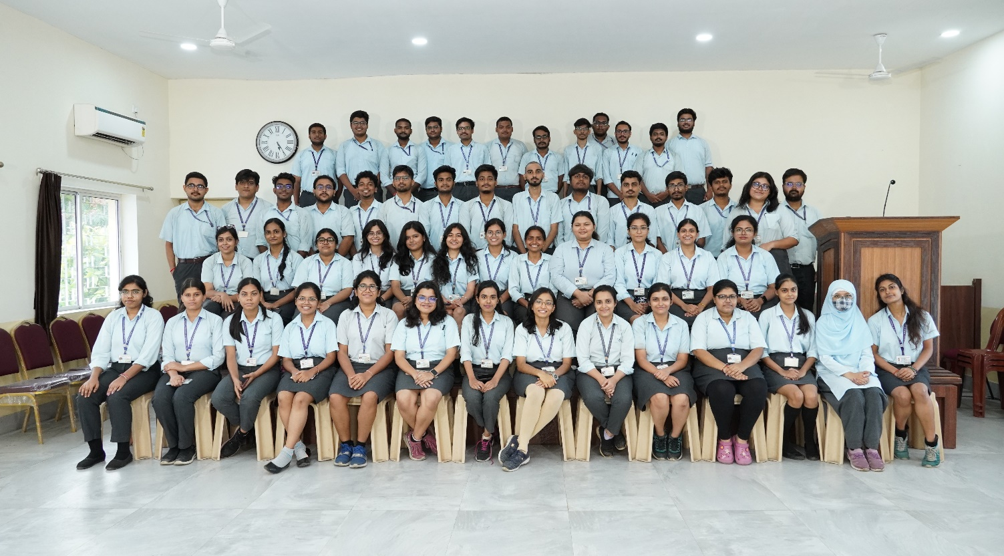

Course Offered by Department of ECE:
B.Tech (in electronics & communication Engineering)

Publisher:
Dr. PRASUN CHOWDHURY
Head of the Department of electronics & communication Engineering
St. Thomas’ College of Engineering & Technology, Kolkata

